**GOVERNMENT POLYTECHNIC MUMBAI**

**(Department of Information Technology)**



**Project Report**

**On**

**COLLEGE WEBSITE MANAGEMENT**

**Presented By:**

|  |  |
| --- | --- |
| Enrollment Number | Name |
| FS16IF046 | **Shaikh Mohammed Abrar** |
| FS16IF051 | **Pritam Turalkar** |

ACKNOLEDGEMENTS:

Before we get into the thick of the thing. We would like to add a few heartfelt words for the people who have been behind this project. We know this project is important for us and this is our final year project so this topic is taken by us after a very long discussion with our seniors and friends. And now we think to complete this project, because this is our current semester subject.

We would like to voice my sincere thanks giving to Dr.R.A.Patil (HOD of IT) and Miss Namrata A. Wakhande our lecturers for providing us with such a high potential opportunity. We hope we have utilized it to the best of your expectation.

The successful completion of our project would not have been possible without the dedicated support from all members, family and friends.

ABSTRACT:

A website is a collection of **Web pages**, images, videos and other digital assets that is hosted on one or several **Web server**, usually accessible via the **Internet, Mobile phone or a LAN.**

The pages of websites can usually be accessed from a common root **URL** called the index, and usually reside on the same physical server. The URLs of the pages organize them into a hierarchy, although the hyperlinks between them control how the reader perceives the overall structure and how the traffic flows between the different parts of the sites.

The college website (i.e. Government Polytechnic Mumbai) has been developed using many languages including the HTML, CSS, JAVASCRIPT as the Front End and the PHP (My SQL Server) as the Back End.

The **college’s website** has developed by our seniors of **Information Technology** Department. This project was developed because our current website is static, and we need for a dynamic and an interactive website.

The college website’s maintenance and deployment has been handled to us by our Department **H.O.D Dr. R.A.Patil** and **Miss Namrata A. Wakhande** as our final year project in the final year of our Diploma Program.

TABLE OF CONTENTS:

CHAPTER TITLE PAGE NO

1 INTRODUCTION 6

1. ABOUT THE TOPIC 6
2. ABOUT THE PROJECT 6

2 SYSTEM ANALYSIS 7

1. INTRODUCTION 8
2. EXISTING SYSTEM 8
3. PROPOSED SYSTEM 9
4. FEATURES OF SOFTWARE 9

2.4.1HTML, CSS, JS - FRONT END 9

2.4.2 PHP- BACK END 12

1. SOFTWARE REQUIREMENTS 14
2. HARDWARE REQUIREMENTS 14

3 SYSTEM DESIGN 15

1. INTRODUCTION 15
2. TABLE DESIGN 15
3. DATABASE DESIGN 16
   * 1. NORMALISATION 17

3.3FIGURES 18

3.4HOME PAGE 20

3.5LINKS AND WEB PAGES 21

1. **SYSTEM TESTING 24**

5.1SYSTEM TESTING 24

5.1.1UNIT TESTING 24

5.1.2INTEGRATION TESTING 25

5.1.3VALIDATION TESTING 26

5.1.4OUTPUT TESTING 27

**4 CONCLUSION 28**

**5 REFERENCES 29**

**CHAPTER-1**

INTRODUCTION:

**1.1 ABOUT THE TOPIC:**

A website is a collection of [Web pages,](http://en.wikipedia.org/wiki/Web_page) images, videos and other digital assets that is hosted on one or several [Web server,](http://en.wikipedia.org/wiki/Web_server) usually accessible via the [Internet,](http://en.wikipedia.org/wiki/Internet) [cell phone](http://en.wikipedia.org/wiki/Cell_phone) or a [LAN.](http://en.wikipedia.org/wiki/LAN)

The pages of websites can usually be accessed from a common root [URL](http://en.wikipedia.org/wiki/URL) called the [homepage,](http://en.wikipedia.org/wiki/Homepage) and usually reside on the same physical server. The URLs of the pages organize them into a hierarchy, although the [hyperlinks](http://en.wikipedia.org/wiki/Hyperlink) between them control how the reader perceives the overall structure and how the [traffic](http://en.wikipedia.org/wiki/Web_traffic) flows between the different parts of the sites.

A website requires attractive design and proper arrangement of links and images, which enables a browser to easily interpret and access the properties of the site. Hence it provides the browser with adequate information and functionality about the organization, community, network etc.

**1.2 ABOUT THE PROJECT:**

The website has been developed for our college (GPM) in an effort to make it as attractive and dynamic as possible. Compared to the existing site a database has been added to our project.

The working of the project is as follows.

The first page provides several links. The Home page contains several information about the site like institute, management, departments, department’s respective facilities and faculties, infrastructure of institute, Gallery, Centers etc.

In the Admission link the following particular information is displayed which includes Diploma Programs in which it will list the information about the seats available in a particular department, and many more etc.

The flash news and the events corner display the latest developments, announcements and events associated with the college activities.

In the Student Section Link there are various information available which includes Academic calendar which contains the information about start and end of semester, list of holidays and many more; Curriculum which displays the syllabus of the particular departments and many more; etc.

The administrator has the responsibility for displaying the recruiters form on the notice board, in response to which student can submit his willingness to attend the drive along with his resume.

**CHAPTER-2**

SYSTEM ANALYSIS:

**2.1 INTRODUCTION**

System analysis is the process of gathering and interpreting facts, diagnosing problems and using the information to recommend improvements on the system. System analysis is a problem solving activity that requires intensive communication between the system users and system developers.

System analysis or study is an important phase of any system development process. The system is studied to the minutest detail and analyzed. The system analyst plays the role of an interrogator and dwells deep into the working of the present system. The system is viewed as a whole and the inputs to the system are identified. The outputs from the organization are traced through the various processing that the inputs phase through in the organization.

A detailed study of these processes must be made by various techniques like Interviews, Questionnaires etc. The data collected by these sources must be scrutinized to arrive to a conclusion. The conclusion is an understanding of how the system functions. This system is called the existing system. Now, the existing system is subjected to close study and the problem areas are identified. The designer now functions as a problem solver and tries to sort out the difficulties that the enterprise faces. The solutions are given as a proposal. The proposal is then weighed with the existing system analytically and the best one is selected. The proposal is presented to the user for an endorsement by the user. The proposal is reviewed on user request and suitable changes are made. This loop ends as soon as the user is satisfied with the proposal.

**2.2 EXISTING SYSTEM**

The existing college website is static which makes it less interactive. It doesn't have a database connectivity. Moreover students didn't have an access to the details of the college through the site, hence they were not updated about the latest events and placement drives.

**2.3 PROPOSED SYSTEM**

In order to make the site dynamic and more interactive we have tried to include a database link to our college website. Hence the recruiters have been provided with the facility to post their eligibility criteria, vacancies and salary packages. In response to which a student can submit his willingness to appear for the drive along with his personal details. Provision has also been made to display the latest events and announcements associated with the college online. We have used the following languages.

**2.4 FEATURES OF SOFTWARES:**

**2.4.1 HTML (Front End):**

HTML stands for hyper text markup Language. It is very useful to make web pages and very easy to learn. Hyper text Markup file is a text file containing small markup tags. These marks up tags tell the browser how to display a web page. It has two types of extensions one is .htm and second is .htmlbut both are used for html web pages. For hyper text mark up language you can use the simple text editor for example; use notepad for writing your HTML code in the windows. If you are using Mac you can use simple text editor.   
  
 HTML uses approach of what you see is what you get. You can also use to write tags other software that is FrontPage and Dreamweaver. In HTMLcharacter are surrounded by the tags. HTML tags come in pair. The beauty of this language is that it is not case sensitive. Every web page need HTMLwith it you can not make the good web pages. And it is the base for every web page and used to display the text in the web pages there are some other latest version of HTML like DHTML which stands for dynamic html and is used to make the web pages more interactive. It is very easy to understand and can be learn very quickly.

Features of HTML are as follows:

1. **Video elements**: Designers can now build web pages without having to resort to third-party proprietary plug-in software like Flash. **YouTube** is experimenting with using HTML 5 to display video. Built in video controls makes the feature more attractive and easy to use.
2. **Application cache**: On the lines of Outlook but minus the email client requirement, you can now store web apps much like emails locally. Google has already made use of this feature replacing its Google Gears mail client with HTML 5. **Google Wave** also uses HTML 5
3. **Canvas for Images**: The canvas element that comes with HTML 5 lets you manipulate graphics and photos enabling easy rendering of images. Designers no longer need to use intermediate technologies like jQuery. This will help save development time and effort.
4. **Geolocation**: The [**HTML5 Geolocation**](http://www.dharne.com/html5-and-the-geolocation-feature/) feature enables location identification using various geo location technologies GPS (Global Positioning system), IP address, RFID (Radio frequency ID), Wi-Fi, Bluetooth MAC address and GSM/CDMA cell IDs. The system is bound by privacy regulations and needs to be authorized by individuals before it can be utilized.
5. **Web workers:**This feature enables a web application to execute complex tasks independently without interfering with the performance of a webpage in real-time.
6. **Better Offline Browsing**: HTML 5 provides excellent facilities for offline browsing. Designers building pages with HTML 5 can now specify the files or pages which need to be cached. This ensures that while trying to reload the pages, with no Internet connection, the pages are displayed in minimum time.

**2.4.1 CSS (Front End):**

**C**ascading **S**tyle **S**heets, fondly referred to as CSS, is a simple design language intended to simplify the process of making web pages presentable.

CSS handles the look and feel part of a web page. Using CSS, you can control the color of the text, the style of fonts, the spacing between paragraphs, how columns are sized and laid out, what background images or colors are used, layout designs, variations in display for different devices and screen sizes as well as a variety of other effects.

CSS is easy to learn and understand but it provides powerful control over the presentation of an HTML document. Most commonly, CSS is combined with the markup languages HTML or XHTML.

**Advantages of CSS are as follows:**

* **CSS saves time** – You can write CSS once and then reuse same sheet in multiple HTML pages. You can define a style for each HTML element and apply it to as many Web pages as you want.
* **Pages load faster** − If you are using CSS, you do not need to write HTML tag attributes every time. Just write one CSS rule of a tag and apply it to all the occurrences of that tag. So less code means faster download times.
* **Easy maintenance** − To make a global change, simply change the style, and all elements in all the web pages will be updated automatically.
* **Superior styles to HTML** − CSS has a much wider array of attributes than HTML, so you can give a far better look to your HTML page in comparison to HTML attributes.
* **Multiple Device Compatibility** − Style sheets allow content to be optimized for more than one type of device. By using the same HTML document, different versions of a website can be presented for handheld devices such as PDAs and cell phones or for printing.
* **Global web standards** − Now HTML attributes are being deprecated and it is being recommended to use CSS. So its a good idea to start using CSS in all the HTML pages to make them compatible to future browsers.

**2.4.1 JAVASCRIPT (Front End):**

Javascript is a dynamic computer programming language. It is lightweight and most commonly used as a part of web pages, whose implementations allow client-side script to interact with the user and make dynamic pages. It is an interpreted programming language with object-oriented capabilities.

JavaScript was first known as **LiveScript,** but Netscape changed its name to JavaScript, possibly because of the excitement being generated by Java. JavaScript made its first appearance in Netscape 2.0 in 1995 with the name **LiveScript**. The general-purpose core of the language has been embedded in Netscape, Internet Explorer, and other web browsers.

* JavaScript is a lightweight, interpreted programming language.
* Designed for creating network-centric applications.
* Complementary to and integrated with Java.
* Complementary to and integrated with HTML.
* Open and cross-platform

**Advantages of JavaScript:**

The merits of using JavaScript are −

* **Less server interaction** - You can validate user input before sending the page off to the server. This saves server traffic, which means less load on your server.
* **Immediate feedback to the visitors**−They don't have to wait for a page reload to see if they have forgotten to enter something.
* **Increased interactivity**- You can create interfaces that react when the user hovers over them with a mouse or activates them via the keyboard.
* **Richer interfaces**- You can use JavaScript to include such items as drag-and-drop components and sliders to give a Rich Interface to your site visitors.

**Limitations of JavaScript:**

We cannot treat JavaScript as a full-fledged programming language. It lacks the following important features −

* Client-side JavaScript does not allow the reading or writing of files. This has been kept for security reason.
* JavaScript cannot be used for networking applications because there is no such support available.
* JavaScript doesn't have any multithreading or multiprocessor capabilities.
  + 1. **PHP (Back End):**

The most popular server-side language on the web, PHP is designed to pull and edit information in the database. It’s most commonly bundled with databases written in the SQL language. PHP was designed strictly for the web and remains one of the most widely used languages around. It’s easy to install and deploy, is staying competitive with lots of modern frameworks, and is the foundation for a number of content-management systems. *PHP-powered sites: Word Press, Wikipedia, Facebook*.

Features of PHP are as follows:

**Simple**

It is very simple and easy to use, compare to other scripting language it is very simple and easy, this is widely used all over the world.

**Interpreted**

It is an interpreted language, i.e. there is no need for compilation.

**Faster**

It is faster than other scripting language e.g. asp and jsp.

**Open Source**

Open source means you no need to pay for use php, you can free download and use.

**Platform Independent**

PHP code will be run on every platform, Linux, Unix, Mac OS X, Windows.

**Case Sensitive**

PHP is case sensitive scripting language at time of variable declaration. In PHP, all keywords (e.g. if, else, while, echo, etc.), classes, functions, and user-defined functions are NOT case-sensitive.

**Error Reporting**

PHP have some predefined error reporting constants to generate a warning or error notice.

**Real-Time Access Monitoring**

PHP provides access logging by creating the summary of recent accesses for the user.

**Loosely Typed Language**

PHP supports variable usage without declaring its data type. It will be taken at the time of the execution based on the type of data it has on its value.

**2.5 SOFTWARE REQUIREMENTS**

OPERATING SYSTEM BROWSER FRONT

FRONT END

BACK END

DATABASE: WINDOWS XP

: INTERNET EXPLORER 6.0 OR ANY HTTP

: HTML, CSS , JS

: XAMPP/WAMP

: MySQL

**2.6 HARDWARE REQUIREMENTS**

|  |  |
| --- | --- |
| PROCESSOR | : PENTIUM IV |
| CLOCK SPEED | : 2 GHZ |
| SYSTEM BUS | : 32 BIT |
| RAM | : 128 MB |
| HDD | : 40GB |
| MONITOR | : SVGA COLOR |
| KEY BOARD | : 108 KEYS |
| MODEM | : 56 KBPS |
| MOUSE | : PS/2 |
|  |  |

**CHAPTER-3**

SYSTEM DESIGN:

**3.1 INTRODUCTION:**

System design is the solution to the creation of a new system. This phase is composed of several systems. This phase focuses on the detailed implementation of the feasible system. It emphasis on translating design specifications to performance specification. System design has two phases of development logical and physical design.

During logical design phase the analyst describes inputs (sources), out puts (destinations), databases (data sores) and procedures (data flows) all in a format that meats the uses requirements. The analyst also specifies the user needs and at a level that virtually determines the information flow into and out of the system and the data resources. Here the logical design is done through data flow diagrams and database design.

The physical design is followed by physical design or coding. Physical design produces the working system by defining the design specifications, which tell the programmers exactly what the candidate system must do. The programmers write the necessary programs that accept input from the user, perform necessary processing on accepted data through call and produce the required report on a hard copy or display it on the screen.

* 1. TABLE DESIGN:

3.2.1Table to store information about faculty of particular department.

|  |  |  |
| --- | --- | --- |
| FIELD | TYPE | CONSTRAINTS |
| Id | Int | Primary_Key |
| Faculty_name | Varchar | Null |
| department | Varchar | Null |
| designation | Varchar | Null |
| Photo_path | Varchar | Null |
| Ext_no | Int | null |

3.2.1Table to display information a current news about the particular department of institute.

|  |  |  |
| --- | --- | --- |
| FIELD | TYPE | CONSTRAINTS |
| News_id | Int | Primary_Key |
| News_title | Varchar | Null |
| News_type | Varchar | Null |
| News_link | Varchar | Null |
| News_expiry_date | Date | Null |
| News_expiry_time | time | null |
| News_posted_date | datetime | null |

3.2.3 Table to store information about student of the particular department of institute

|  |  |  |
| --- | --- | --- |
| FIELD | TYPE | CONSTRAINTS |
| E_no | Varchar | Primary_Key |
| student_name | Varchar | Null |
| Student_dept | Varchar | Null |
| Student_email | Varchar | Null |

**3.3DATABASE DESIGN:**

The overall objective in the development of database technology has been to treat data as an organizational resource and as an integrated whole. DBMS allow data to be protected and organized separately from other resources. Database is an integrated collection of data. The most significant form of data as seen by the programmers is data as stored on the direct access storage devices. This is the difference between logical and physical data.

Database files are the key source of information into the system. It is the process of designing database files, which are the key source of information to the system. The files should be properly designed and planned for collection, accumulation, editing and retrieving the required information.

The organization of data in database aims to achieve three major objectives: -

* Data integration.
* Data integrity.
* Data independence.

The proposed system stores the information relevant for processing in the MS SQL SERVER database. This database contains tables, where each table corresponds to one particular type of information. Each piece of information in table is called a field or column. A table also contains records, which is a set of fields. All records in a table have the same set of fields with different information. There are primary key fields that uniquely identify a record in a table. There are also fields that contain primary key from another table called foreign keys.

3.2.1 NORMALIZATION

Normalization is a technique of separating redundant fields and braking up a large table in to a smaller one. It is also used to avoid insertion, deletion and updating anomalies. All the tables have been normalized up to the third normal form. In short the rules for each of the three normal forms are as below.

• First normal form

A relation is said to be in 1NF if all the under lying domain of attributes contain simple individual values.

• Second normal form

The 2NF is based on the concept of full functional dependency. A relation said to be in 2NF if and only if it is in 1NF and every non-key attribute is fully functionally dependent on candidate key of the table.

• Third normal form

The 3NF is based on the concept of transitive dependency. A relation in 2NF is said to be in 3NF if every non-key attribute is non-transitively.

**3.4FIGURES:**

USERS

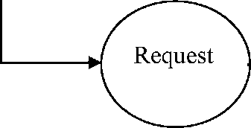

SERVICES

**FIG: DFD FOR ACCESSING WEB PAGES**

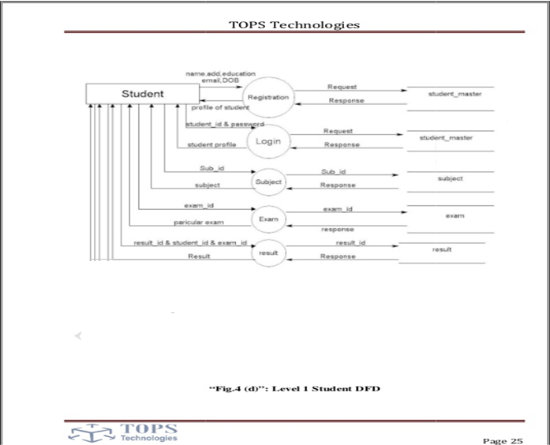**FIG: DFD FOR STUDENT**

**3.5 HOME PAGE**

The home page of a website is the first page that a user perceives upon entering the website url at the browser address area. The entire website depends on how the home page is designed which forms the platform for viewing other web forms. In short, a home page forms the abstract of the entire website.

The SNGCE website begins with an interactive home page in which a recruiter username and password can be entered. A validation is performed at the database to verify whether the recruiter is an already authorized user, if not a recruiter is allowed to sign in by filling up the necessary details on a form. The home page appears as given below.

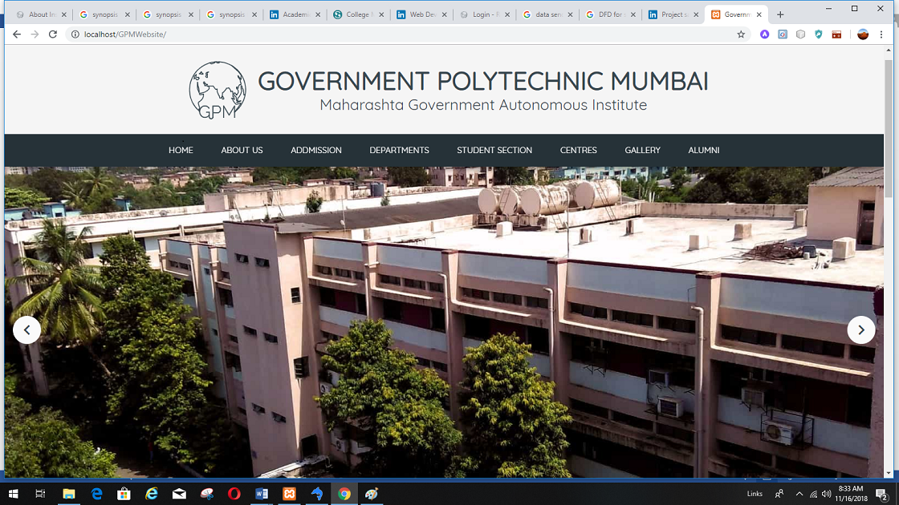**FIG: HOME PAGE:**

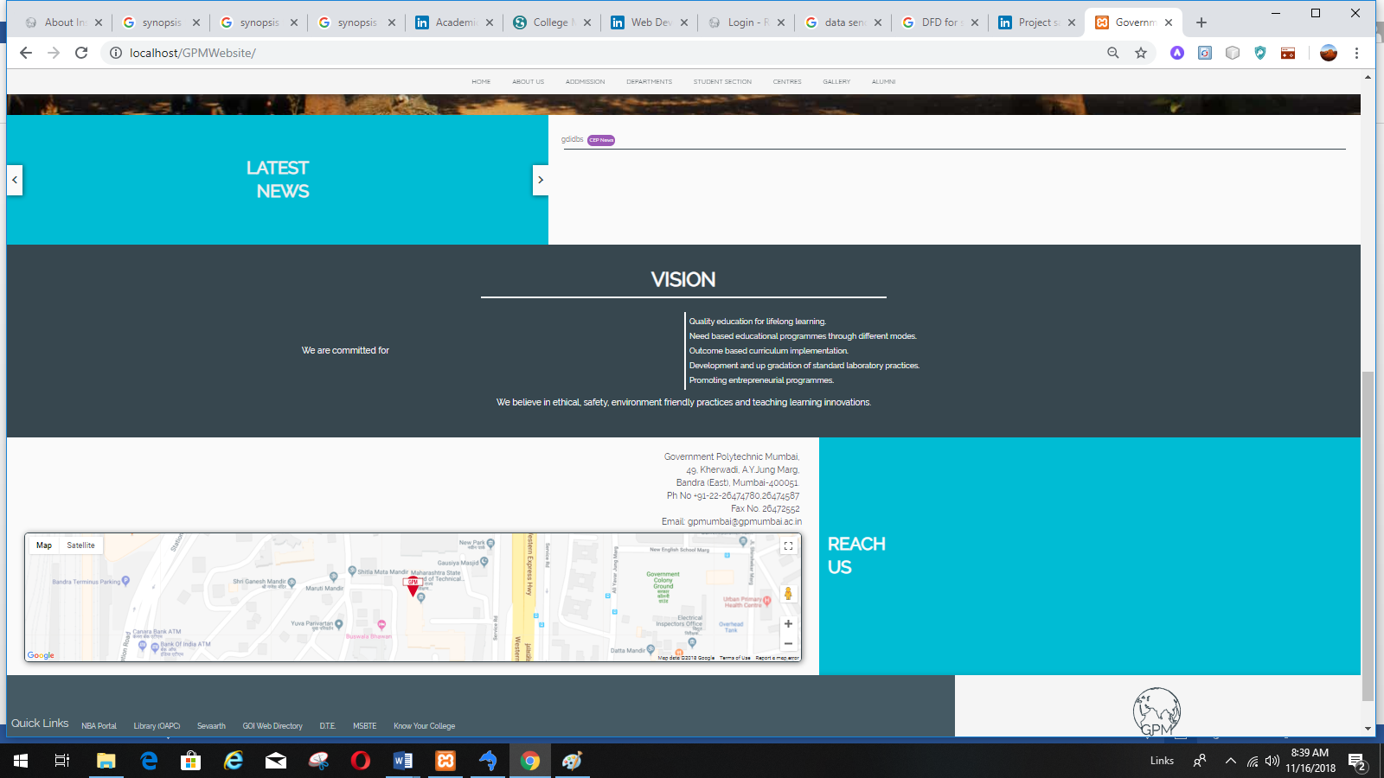**FIG: HOME PAGE (Scroll Down):**

**3.5LINKS AND WEBPAGES:**

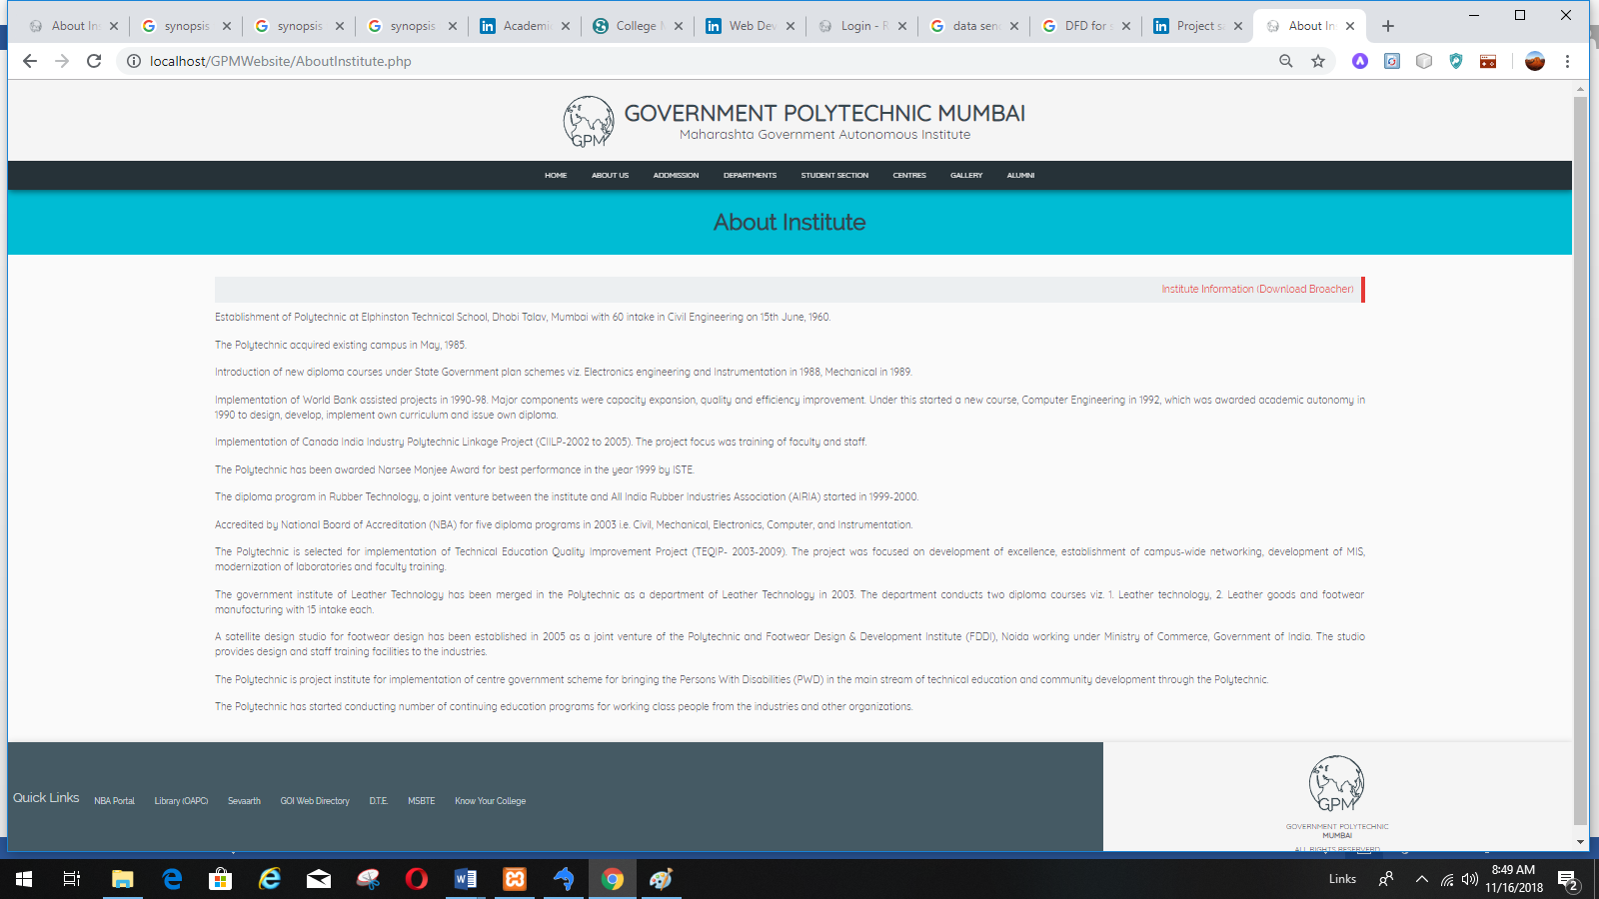

**FIG: Link to About Institute of About Us in Home Page**

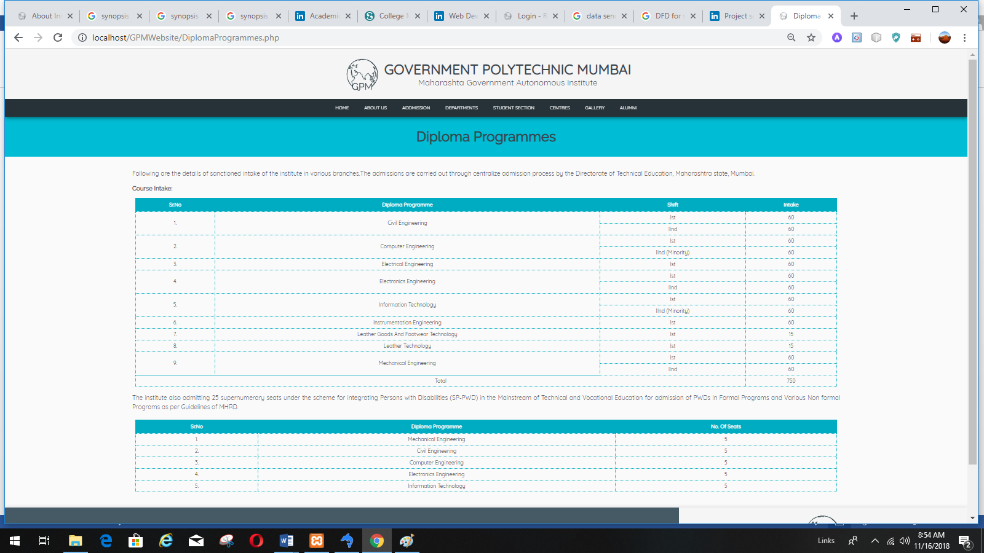 **FIG: Link to Diploma Programs of Admission in Home Page**

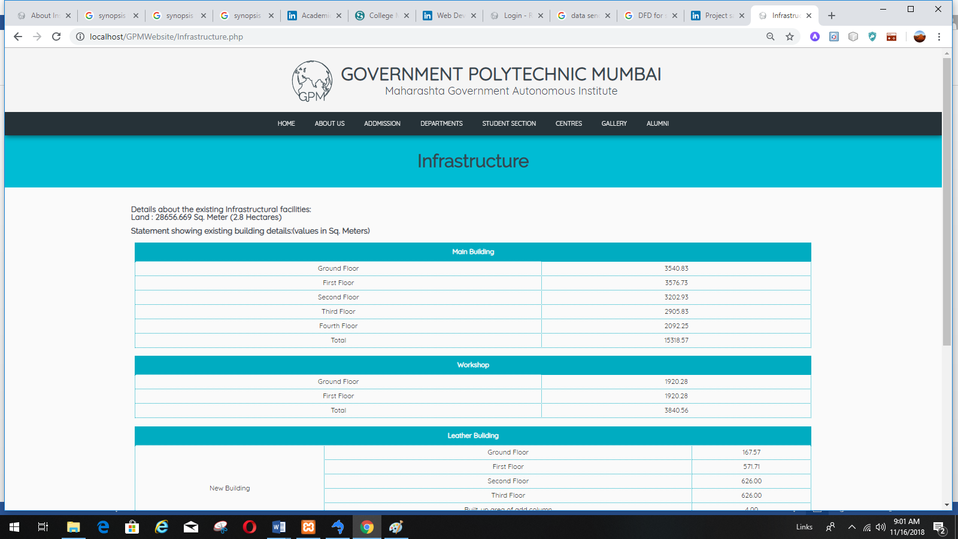

**FIG: Link to Infrastructure of About Us in Home Page**

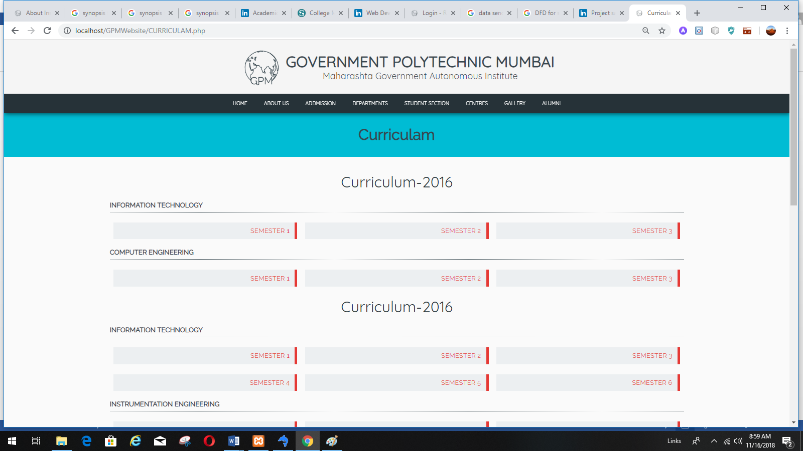

**FIG: Link to Curriculum of Student Section in Home Page**

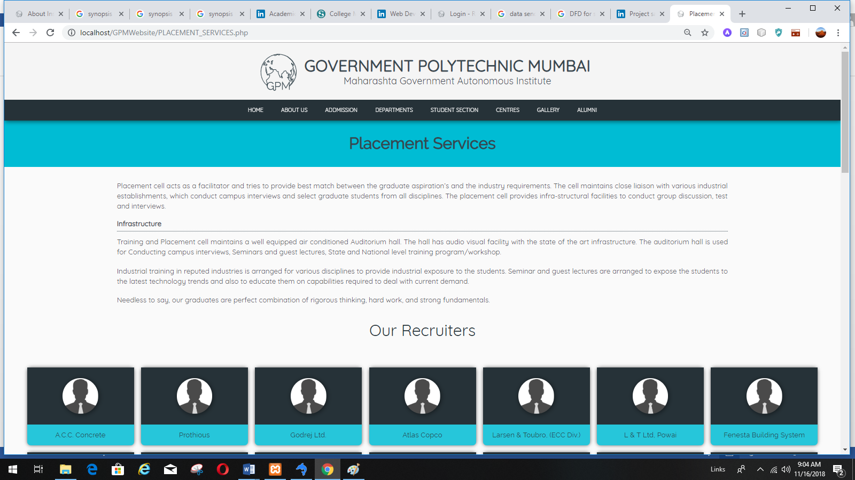

**FIG: Link to Placement Service of Centers Section in Home Page**

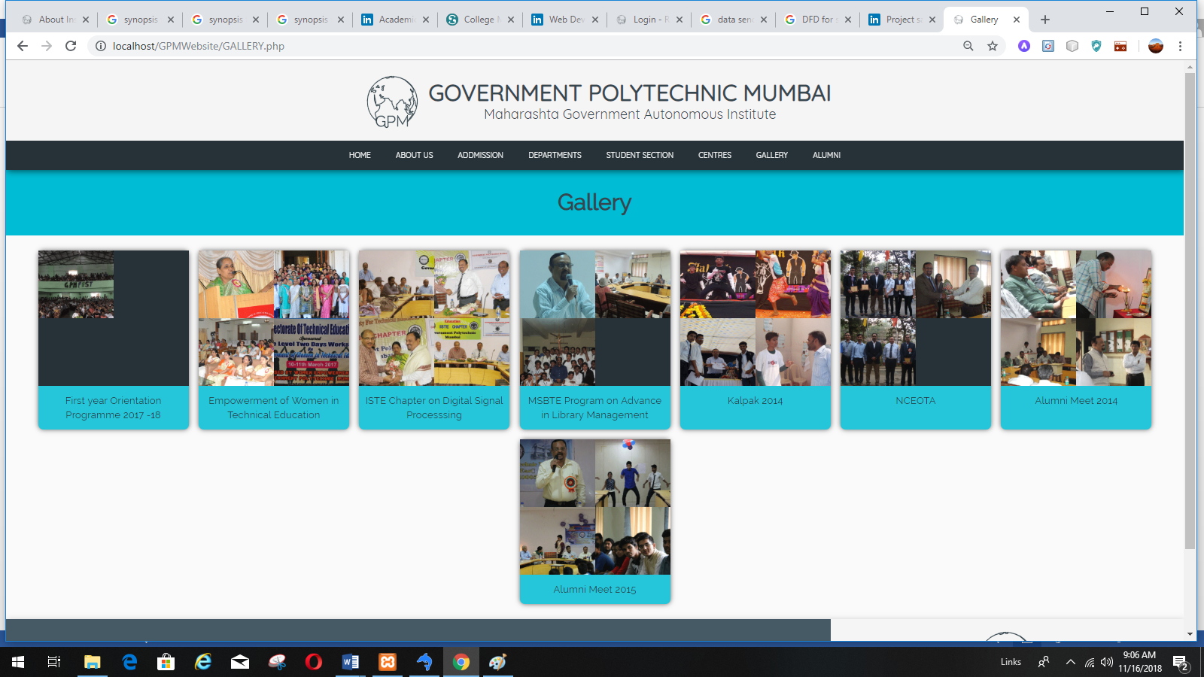

**FIG: Link to Gallery Section in Home Page**

**CHAPTER-4**

TESTING:

**5.1 SYSTEM TESTING**

Testing is a set activity that can be planned and conducted systematically. Testing begins at the module level and work towards the integration of entire computers based system. Nothing is complete without testing, as it is vital success of the system.

• Testing Objectives:

There are several rules that can serve as testing objectives, they are

1. Testing is a process of executing a program with the intent of finding an error
2. A good test case is one that has high probability of finding an undiscovered error.
3. A successful test is one that uncovers an undiscovered error.

If testing is conducted successfully according to the objectives as stated above, it would uncover errors in the software. Also testing demonstrates that software functions appear to the working according to the specification, that performance requirements appear to have been met.

There are three ways to test a program

1. For Correctness
2. For Implementation efficiency
3. For Computational Complexity.

Tests for correctness are supposed to verify that a program does exactly what it was designed to do. This is much more difficult than it may at first appear, especially for large programs.

Tests for implementation efficiency attempt to find ways to make a correct program faster or use less storage. It is a code-refining process, which reexamines the implementation phase of algorithm development.

Tests for computational complexity amount to an experimental analysis of the complexity of an algorithm or an experimental comparison of two or more algorithms, which solve the same problem.

• Testing Correctness

The following ideas should be a part of any testing plan:

1. Preventive Measures
2. Spot checks
3. Testing all parts of the program
4. Test Data
5. Looking for trouble
6. Time for testing
7. Re Testing

The data is entered in all forms separately and whenever an error occurred, it is corrected immediately. A quality team deputed by the management verified all the necessary documents and tested the Software while entering the data at all levels. The entire testing process can be divided into 3 phases

1. Unit Testing
2. Integrated Testing
3. Final/ System testing

**5.1.1 UNIT TESTING**

As this system was partially GUI based WINDOWS application, the following were tested in this phase

1. Tab Order
2. Reverse Tab Order
3. Fie ld length
4. Front end validations

In our system, Unit testing has been successfully handled. The test data was given to each and every module in all respects and got the desired output. Each module has been tested found working properly.

**5.1.2 INTEGRATION TESTING**

Test data should be prepared carefully since the data only determines the efficiency and accuracy of the system. Artificial data are prepared solely for testing. Every program validates the input data.

**5.1.3 VALIDATION TESTING**

In this, all the Code Modules were tested individually one after the other. The following were tested in all the modules

1. Loop testing
2. Boundary Value analysis
3. Equivalence Partitioning Testing

In our case all the modules were combined and given the test data. The combined module works successfully without any side effect on other programs. Everything was found fine working.

**5.1.4 OUTPUT TESTING**

This is the final step in testing. In this the entire system was tested as a whole with all forms, code, modules and class modules. This form of testing is popularly known as Black Box testing or system testing.

Black Box testing methods focus on the functional requirement of the software. That is, Black Box testing enables the software engineer to derive sets of input conditions that will fully exercise all functional requirements for a program. Black Box testing attempts to find errors in the following categories; incorrect or missing functions, interface errors, errors in data structures or external database access, performance errors and initialization errors and termination errors.

**CHAPTER-5**

CONCLUSION:

The project report entitled "COLLEGE WEBSITE MANAGEMENT" has come to its final stage. The system has been developed with much care that it is free of errors and at the same time it is efficient and less time consuming. The important thing is that the system is robust. We have tried our level best to make the site as dynamic as possible. Also provision is provided for future developments in the system. The entire system is secured. This online system will be approved and implemented soon.

**CHAPTER-6**

REFERENCES:

* 1. HTML From Wikipedia:

<https://en.wikipedia.org/wiki/HTML>

* 1. <https://www.tutorialspoint.com/css/what_is_css.htm>
  2. <https://www.tutorialspoint.com/javascript/javascript_overview.htm>
  3. PHP-The Complete Reference Book
  4. HTML5 and CSS3 For The Real World (Estelle Weyl,et al)